[Fish and Shellfish Immunology 108 (2021) 7–13](https://doi.org/10.1016/j.fsi.2020.11.014)

Systemic and mucosal antibody response of freshwater cultured Asian seabass (*Lates calcarifer*) to monovalent and bivalent vaccines against *Streptococcus agalactiae* and *Streptococcus iniae*



Full length article



Contents lists available at

ScienceDirect

Fish and Shellfish Immunology

journal homepage:

www.elsevier.com/locate/fsi

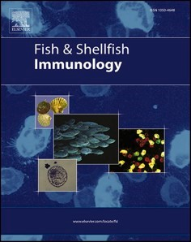

Nguyen Giang Thu Lan a,b, Krishna R. Salin b,*, Siwaporn Longyant c, Saengchan Senapin d,e, Ha Thanh Dong f,**

1. *School of Biotechnology, International University-Vietnam National University, Ho Chi Minh City, Viet Nam*
2. *Aquaculture and Aquatic Resources Management, Department of Food, Agriculture and Bioresources, School of Environment Resources and Development, Asian Institute of Technology, Khlong Luang, Pathumthani, 12120, Thailand*
3. *Department of Biology, Faculty of Science, Srinakharinwirot University, Bangkok, 10110, Thailand*
4. *Fish Health Platform, Center of Excellence for Shrimp Molecular Biology and Biotechnology (Centex Shrimp), Faculty of Science, Mahidol University, Bangkok, 10400, Thailand*
5. *National Center for Genetic Engineering and Biotechnology (BIOTEC), National Science and Technology Development Agency (NSTDA), Pathumthani, 12120, Thailand* f *Faculty of Science and Technology, Suan Sunandha Rajabhat University, Bangkok, 10300, Thailand*

A R T I C L E I N F O A B S T R A C T

|  |  |
| --- | --- |
| *Keywords:*  Asian seabass  *Lates calcarifer*  *Streptococcus agalactiae Streptococcus iniae*  Inactivated vaccines Antibody response | Asian seabass, *Lates calcarifer* farming in Southeast Asia, encounters serious disease challenges caused by *Streptococcus agalactiae* and *Streptococcus iniae*. However, a vaccine for disease prevention is not yet available. In this study, we investigated the mucosal and systemic antibody (IgM) response kinetics of the Asian seabass following primary immunization with oil-based formalin-killed vaccines (FKVs) prepared from *S. agalactiae* and *S. iniae* (monovalent Sa, monovalent Si, and bivalent Sa-Si) and secondary booster with the respective water- based FKVs. The efficacy of vaccines was subsequently evaluated by an experimental challenge. The results revealed similar antibody response kinetics in both systemic and mucosal systems. However, the immune response in the fish vaccinated with the monovalent vaccines was superior to those fish received the bivalent vaccine in terms of specific antibody titer. The fish that received monovalent vaccines required 1–2 weeks to raise a significant level of specific antibody titer in both systemic and mucosal systems while those vaccinated with bivalent vaccine required three weeks. Following booster at day 21, both systemic and mucosal antibody titers in all vaccinated groups had reached the peak at day 28 and gradually declined in the following weeks but remained significantly higher than control until the end of the experiment (day 63). In the challenge test, both monovalent and bivalent vaccines were found to be highly efficacious, with the relative percentage survival (RPS) ranging from 75 to 85%. In summary, this study explored the 63-days antibody response kinetics (both mucosal and systemic systems) of Asian seabass to monovalent and bivalent inactivated vaccines and confirmed that the combination of *S. agalactiae* and *S. iniae* in a single injectable vaccine is possible. |

# 1. Introduction

Asian seabass, *Lates calcarifer*, is an economically important species in the tropical and subtropical areas of the Asia-Pacific region such as Australia, China, Indonesia, Malaysia, Thailand, and Taiwan [1–3]. It has a high fecundity, can tolerate crowding, is eurythermal and euryhaline, and grows fast to big size in both fresh and saltwater [4,5].

|  |  |
| --- | --- |
| |  | | --- | | * Corresponding author.  ** Corresponding author. |   *E-mail addresses:* salinkr@ait.ac.th (K.R. Salin), hathanh.do@ssru.ac.th (H.T. Dong). <https://doi.org/10.1016/j.fsi.2020.11.014>  Received 18 June 2020; Received in revised form 22 August 2020; Accepted 14 November 2020 Available online 18 November 2020  1050-4648/© 2020 Elsevier Ltd. All rights reserved. |

However, several microbial pathogens infect Asian seabass at different stages of its lifecycle resulting in diseases such as viral nervous necrosis [6–8], scale drop disease [9,10], infectious spleen and kidney necrosis disease [11,12], vibriosis [13,14] and streptococcosis [15–19]. Among these, *Streptococcus* bacterial infection represents one of the major threats to seabass aquaculture worldwide, causing mass mortality and substantial economic loss in most of the production systems [20].

The bacteria, *Streptococcus agalactiae,* and *S. iniae* are the two primary etiological agents of streptococcosis. In Asian seabass, the disease caused by *S. iniae* characterized by hemorrhage on skin and fins, and protruding eyes was first reported in Australia in 1999 [15]. The disease continued to affect seabass farmed in Australia, with mortality up to 70% in the early life stages, as reported in 2006 [16]. Streptococcosis caused by *S. iniae* was also reported in farmed Asian seabass in Thailand and Vietnam [18,21]. Recently, Asian seabass has been cultured in freshwater systems in Southeast Asia, which is a favorable environment for *S. agalactiae*, making Asian seabass vulnerable to *S. agalactiae* infection, similar to tilapia [22].

Vaccination in aquaculture has been applied to provide and assist in eliciting a long-lasting specific immune response against pathogens in farmed fish. Currently, most commercial vaccines comprise inactivated pathogens administered by injection, which is a practical mode for farmers to adopt [23]. However, vaccination procedure in fish in the aquatic environment is more challenging compared to that in terrestrial livestock. The development of vaccines against infectious pathogens in Asian seabass is still on a limited scale. Moreover, in Asian seabass, like other teleosts, the immunoglobulin class M (IgM) that is present in both the serum and mucus secretions plays a vital role in the adaptive immune system [24,25]. There is a paucity of research on the development of monovalent and bivalent vaccines for protecting Asian seabass against *S. agalactiae* and *S. iniae* infections. This is a major impediment in the ongoing efforts to curtail streptococcosis in seabass farming systems.

The present study reports the development of monovalent and bivalent vaccines against *S. agalactiae* and *S. iniae* infection in Asian seabass and the evaluation of the titer of the systemic and mucosal antibody responses and protective efficacy in laboratory challenge. This approach might be an important and reliable tool to mitigate streptococcosis disease in farmed Asian seabass.

# 2. Materials and methods

## 2.1. Experimental fish and husbandry

Six hundred and five healthy juveniles of Asian seabass (19.7 ± 2 g) were obtained from a local farm in Thailand. The fish was acclimatized in freshwater in three circular concrete tanks (~4000-L capacity) supplied with continuous aeration. The fish were fed with commercial pellets at 2% of body weight (Profeed, floating feed for carnivorous marine finfish, 42% crude protein, Thai Union Feedmill, Thailand), twice daily. Water quality parameters (temperature, 26–32 ◦C; pH, 7.5–8.5; salinity, 0 ppt; NH3, *<*1 ppm; dissolved oxygen, 4–9 ppm) were checked daily during the experiment period. Before immunization, five fish were randomly collected for bacterial isolation to examine for the presence of *Streptococcus* and found to be undetectable. The fish reached 27.4 ± 1.3 g at the time of vaccination and 56.2 ± 0.6 g at the time of the challenge test.

## 2.2. Preparation of bacterial culture and formalin-killed vaccines

The bacterial strains of *S. agalactiae* SBVN serotype Ia [22] and *S. iniae* 1810 isolated from diseased Asian seabass were from Centex Shrimp collection. For the formulation of the inactivated bacterial vaccines, bacteria from frozen glycerol stocks were recovered on tryptic soy agar (TSA) for 24 h at 30 ◦C before being cultured in 100 mL of tryptic soy broth (TSB) (Becton, Dickinson and Company, USA) for 24 h at 30 ◦C with shaking. After harvesting, the bacterial cells of *S. agalactiae* and *S. iniae* were inactivated by adding formalin to a final concentration of 3%(v/v) and incubated overnight at 4 ◦C. The inactivation of bacteria was verified by plating 0.1 mL of the killed bacterial suspension on TSA and incubating at 30 ◦C for three days. The lack of bacterial growth indicated successful inactivation. The inactivated bacterial suspension was then washed with 1× phosphate-buffered saline (1× PBS) and harvested by centrifugation at 4500 rpm, 4 ◦C for 5 min. The bacterial pellet was then resuspended with 1× PBS and adjusted to OD600 nm = 1.3 (equivalent to ~109 CFU/mL) for vaccine formulation. The monovalent oil-based vaccines were prepared by mixing the suspension of formalin-killed *S. agalactiae* or *S. iniae* with incomplete Freund’s adjuvant (IFA) (Sigma-Aldrich, USA) at the ratio 1:1 (v/v) while the bivalent vaccine was prepared by mixing an equal volume of each monovalent vaccine. Formulation of 1× PBS with IFA was used as a mock vaccine control. Each vaccine mixture was homogenized by vortexing for 20 min and kept at 4 ◦C until use. Similarly, the prepared bacterial suspensions without adjuvant were used as water-based vaccines, while 1× PBS was used as a control for booster vaccination. The adjuvant was used only in primary immunization for enhancing the host immune response to vaccines. On the other hand, only antigens without an adjuvant were used in booster immunization to avoid overreaction of the immune system (e.g., acute inflammation) and other potential side effects (e.g., adhesions in internal organs). *2.3. Fish immunization and sample collection*

The use of fish in this study was approved by the Animal Care and Use Committee (MUSC63-014-522). Fish were distributed randomly into four groups, with 150 fish per group. Each group was reared in freshwater in three circular cement tanks (~500-L capacity) with 50 fish per tank. Before vaccination, fish were anesthetized with 20 ppm of clove oil. Each fish was then intraperitoneally injected with 0.1 mL of the prepared vaccines (equivalent to 0.5 × 109 CFU) with a 23-G needle. A booster with the corresponding water-based vaccine was administered at day 21 post-primary immunization by injection in the same manner. Vaccinated fish were maintained until 63 days before the challenge test.

Mucus and serum samples were collected from six fish belonging to each group on days 0, 7, 14, 21, 28, 35, 42, 49, 56, and 63. For mucus samples, each fish was placed inside a clear plastic bag containing 3 mL of 1× PBS supplemented with 0.02% sodium azide [26], and the bag rubbed gently to collect mucus. From the same fish, approximately 0.8 mL of blood was withdrawn from the caudal vein using a syringe with a 23-G needle. The collected mucus and blood in sterile tubes were immediately placed on the ice and transported to the laboratory. The supernatant containing antibodies was collected by centrifugation at 5000 rpm for 15 min and refrigerated at − 20 ◦C until use.

## 2.4. Serum antibody assays and mucus antibody analysis

The systemic and mucosal antibody titers in the respective serum and mucus of Asian seabass were determined by ELISA. Flat-bottom microplate wells (Costar®, Corning Inc., USA) were coated with 100 μL/well of *S. iniae* and *S. agalactiae* whole-cell antigen (equivalent to ~108 CFU/ mL) in carbonate coating buffer at pH 9.6, and incubated overnight at 4 ◦C. The wells were washed three times with 1× PBS, containing 0.05% Tween-20 (Amresco, USA) (PBST). To evaluate appropriate dilution for ELISA assay, serum or mucus samples were pooled from three fish for each time course, and 2-fold serially diluted solutions were used. The suitable dilutions for ELISA analysis for serum and mucus were found to be 1:256 and 1:8, respectively. The serum and mucus samples from the remaining three fish of each time point were then individually diluted accordingly in PBST containing 0.2% skimmed milk (PBSTM) and incubated with the bacteria coated plates for 1 h at room temperature. After washing three times with PBST, anti-Asian seabass IgM secondary antibody [27] diluted with PBSTM (1: 50) was added and incubated for 1 h, followed by washing with PBST and adding commercial goat anti-mouse antibody horseradish peroxidase (HRP) conjugate (Thermo Fisher Scientific, USA) diluted in PBSTM (1: 3000) into each well for 1 h. After washing, 3, 3′, 5, 5′-tetramethylbenzidine (TMB) substrate (EMD Millipore Corp, USA) was added, and the wells incubated for 15 min with gentle shaking. The reaction was then stopped by adding 100 μL of 2 M H2SO4 into each well. A microplate reader was used to measure the absorbance at 450 nm [26].

## 2.5. Efficacy trial – laboratory aquarium challenge

The efficacy of vaccines in fish was tested by experimental challenge with the respective bacterial pathogens at day 79 post-immunization. The challenge test was carried out in duplicate in 150 L freshwater tank system, which contained 10 fish each (Table 1). The fish immunized with monovalent vaccines were challenged with either

*S. agalactiae* or *S. iniae* by intraperitoneal injection with 106 CFU/fish. In contrast, the fish from control groups and bivalent vaccine administrated groups were challenged with either PBS, single *S. agalactiae* (106

CFU/fish), single *S. iniae* (106 CFU/fish) or combined two bacteria (5 × 105 CFU *S. agalactiae* and 5 × 105 CFU *S. iniae* per fish) (Table 1). Mortality was recorded for 14 days.

## 2.6. Data analysis

Systemic and mucosal antibody response among the treatment and control groups at each time point and survival rate of the challenged fish were analyzed by one-way ANOVA followed by a Tukey’s posthoc test carried out to determine the mean differences among the groups. Mean values were considered significantly different at *P <* 0.05. Statistical analysis was done using SPSS for Windows version 16.0. The efficacy of vaccination was evaluated by calculating cumulative percent mortality (CPM) of each treatment and relative percent survival (RPS) of the vaccinated groups for two weeks after the challenge using the following formula [29]:

The ​ number ​ of ​ fish ​ deaths ​ recorded

CPM=× 100

​ The ​ total ​ number ​ of ​ fish ​

( )

Average ​ CPM ​ in ​ the ​ vaccinated ​ group

RPS= 1−× 100 Average ​ CPM ​ in ​ the ​ non − vaccinated ​ group

# 3. Results

## 3.1. Systemic antibody response in the immunized Asian seabass

After vaccination, all the treatment groups exhibited similar patterns of systemic antibody response (Fig. 1A). The specific antibody (IgM) levels steadily increased from day 0 to day 21 before administering the booster dose. The antibody titer of the fish that received monovalent Sa and Si vaccines reached a peak on day 14 (0.172 ± 0.008) and day 21 (0.159 ± 0.027), respectively (Fig. 1A). The antibody response of bivalent vaccine groups against *S. agalactiae* and *S. iniae* had the highest point of 0.108 ± 0.005 and 0.113 ± 0.004 both on day 21, respectively (Fig. 1B). After boosting on day 21, serum antibody responses of the vaccinated groups had the peaks at the same time (day 28) and then gradually decreased until day 63. The highest antibody titers of booster

### Table 1

monovalent vaccine vaccination were 0.337 ± 0.028 (Sa) and 0.494 ± 0.015 (Si) (Fig. 1A). The peak of antibody response of booster bivalent vaccine vaccinated group against *S. agalactiae* was 0.247 ± 0.006, and the one against *S. iniae* was 0.280 ± 0.006 (Fig. 1B). Overall, the serum antibody responses in the fish vaccinated with monovalent or bivalent vaccines were significantly higher than those in the control group that received only adjuvant from day 7 onwards until day 63 before the bacterial challenge. Antibody titers of the control groups slightly increased after booster but remained relatively stable and low during the experiment (Fig. 1).

## 3.2. Mucosal antibody response in the immunized Asian seabass

Mucosal antibody response between monovalent and bivalent vaccinated groups displayed a similar pattern (Fig. 2) and slightly increased from day 0–21 before the administration of booster dose. The antibody response in fish groups vaccinated with monovalent Sa and Si vaccines was at its peak on day 21 and day 14, at 0.098 ± 0.009 and 0.159 ± 0.005, respectively. The antibody response of bivalent vaccine groups against *S. agalactiae* and *S. iniae* both peaked on day 21, at 0.087

± 0.000 and 0.113 ± 0.003, respectively. After boosting on day 21, the peak of antibody response of bivalent groups against *S. agalactiae* was 0.196 ± 0.009, and against *S. iniae* was 0.187 ± 0.009 on day 28. The highest antibody response of booster monovalent groups was 0.170 ± 0.010 (Sa) on day 42 and 0.268 ± 0.006 (Si) on day 28. The antibody responses of all vaccinated groups then gradually declined. Mucosal antibody response in fish groups vaccinated by monovalent and bivalent vaccines was significantly higher than those in the control group from day 14 post-immunization through the end of the experiment before the challenge test (Fig. 2).

## 3.3. The efficacy test in the laboratory challenge

The results of the laboratory challenge are shown in Fig. 3. All control groups that received PBS without bacteria survived 100%. However, the non-vaccinated fish in the control groups challenged with either S. agalactiae (Sa), S. iniae (Si) or a combination of both S. agalactiae and S. iniae (Sa-Si) started to die from day 1 and reached 100% mortality after 8-9-days post challenge (Fig. 3). On the other hand, survival rates of the monovalent vaccinated fish challenged with its homologous strain were 75 ± 7.1% for monovalent Sa and 70 ± 0.0% for monovalent Si. The survival rates of 70 ± 0.0%, 80 ± 0.0%, and 85 ± 7.1% were recorded for bivalent vaccinated group challenged with single Sa, single Si, and combined Sa-Si, respectively. There was no significant difference in fish survival between monovalent and bivalent vaccine groups. The relative percent of survival (RPS) were 75% and 70% for monovalent Sa and Si, respectively. In the bivalent vaccine, the

|  |  |  |  |  |  |  |
| --- | --- | --- | --- | --- | --- | --- |
| Group | Number of  fish | Primary immunization (day 0, i.p., 0.1 mL/fish) | Booster (day 21, i.p., 0.1 mL/fish) | Challenge group name (10 fish/tank × 2 replicates) | Challenge dose/fish (day 79, i.p., 0.1 mL/fish) | RPS |
| Control  Monovalent Sa  Monovalent  Si  Bivalent Sa- Si | 150  150  150  150 | PBS + IFA  Sa + IFA (~5 × 108 cells/mL)  Si + IFA (~5 × 108 cells/mL)  Sa-Si + IFA (~2.5 × 108 Sa cells/mL and ~2.5 × 108 Si cells/mL) | PBS  Sa in PBS (~109 cells/mL)  Si in PBS (~109 cells/mL)  Sa-Si in PBS (~0.5 × 108 Sa cells/ mL and ~0.5 × 108 Si cells/mL) | Control (+PBS)  Control (+Sa)  Control (+Si)  Control (+Sa-Si)  Monovalent Sa (+PBS)  Monovalent Sa (+Sa) Monovalent Si (+PBS)  Monovalent Si (+Si) Bivalent Sa-Si (+PBS)  Bivalent Sa-Si (+Sa)  Bivalent Sa-Si (+Si)  Bivalent Sa-Si (+Sa-Si) | PBS  106 CFU Sa  106 CFU Si  0.5 × 106 CFU Sa + 0.5 ×  106 CFU Si  PBS  106 CFU Sa  PBS  106 CFU Si  PBS  106 CFU Sa  106 CFU Si  0.5 × 106 CFU Sa + 0.5 × 106 CFU Si | -  -  -  -  -  75  -  70  -  70  80  85 |

Details of experimental design, vaccination scheme, challenge doses, and fish survival.

Sa, *S. agalactiae*; Si, *S. iniae*; i.p, intraperitoneal injection; IFA, incomplete Freund’s adjuvant; RPS, relative percent survival; -, not applicable.

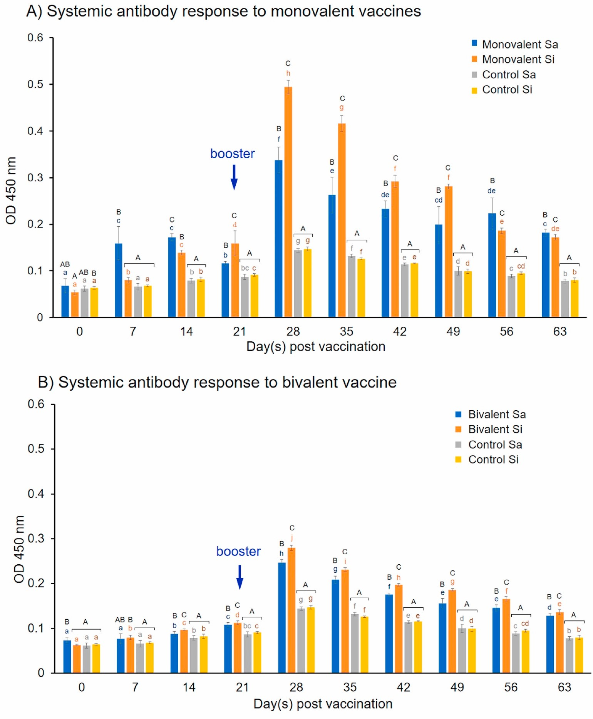

**Fig. 1.** Systemic antibody titers of Asian seabass following immunization with the monovalent inactivated vaccines (A) and bivalent vaccine (B) as determined by ELISA. Serum antibody titer was assayed with 1:256 dilutions, measured at OD 450 nm. Significant differences (P *<* 0.05) within the same days are indicated by capital letters, and significant differences between days are indicated by small letters.

RPS were 70%, 80%, and 85% after challenged with Sa, Si, and Sa-Si, respectively (Table 1).

# 4. Discussion

Based on the results of specific antibody (IgM) response and fish protection from the laboratory challenge, this study revealed that a combination of two pathogenic Gram-positive bacteria, *S. agalactiae* and *S. iniae* in an injected vaccine is highly promising for prevention of streptococcosis disease in Asian seabass. Even though the monovalent vaccines induced better specific IgM levels in both serum and mucus of the immunized fish compared that of the bivalent vaccine, the high RPS values obtained from the bivalent vaccine (70–85%) were not significantly different from those of the monovalent vaccines tested (70–75%). This suggests that the efficacy of the vaccine does not rely on only the level of IgM, but also other factors of the specific immune system, e.g., cell-mediated immunity. In a previous report on cobia (*Rachycentron canadum*), it was found that a bivalent inactivated vaccine enhanced specific and non-specific immune responses and gave 100% protection upon challenge with a highly virulent *Streptococcus dysgalactiae* strain [30]. Successful laboratory demonstration of bivalent inactivated vaccine with high RPS of 89% and 100% against *Vibrio vulnificus* and *S. iniae* in hybrid tilapia (*O. niloticus* × *O. aureus*) has also been reported [31]. Similarly, a trivalent inactivated vaccine formulated from *V alginolyticus, V. parahaemolyticus,* and *Photobacterium damselae* subsp*. piscicida* stimulated both specific antibodies and protection (84.7–93.8% survival) in cobia against corresponding bacterial pathogen infections [28]. For commercial scale, the application of bivalent or multivalent vaccines provides practical advantages over monovalent vaccines since they reduce the number of injections, stress from handling the fish, as well as the time and cost of immunization [32–34]. In the salmon industry, several multivalent vaccines against 3 to 7 pathogens have been commercially available ([https://www.pharmaq.no/products/in](https://www.pharmaq.no/products/injectable/) [jectable/)](https://www.pharmaq.no/products/injectable/). Therefore, a combination of two or more pathogens in one vaccine might be feasible for a younger industry like Asian seabass in Southeast Asia.

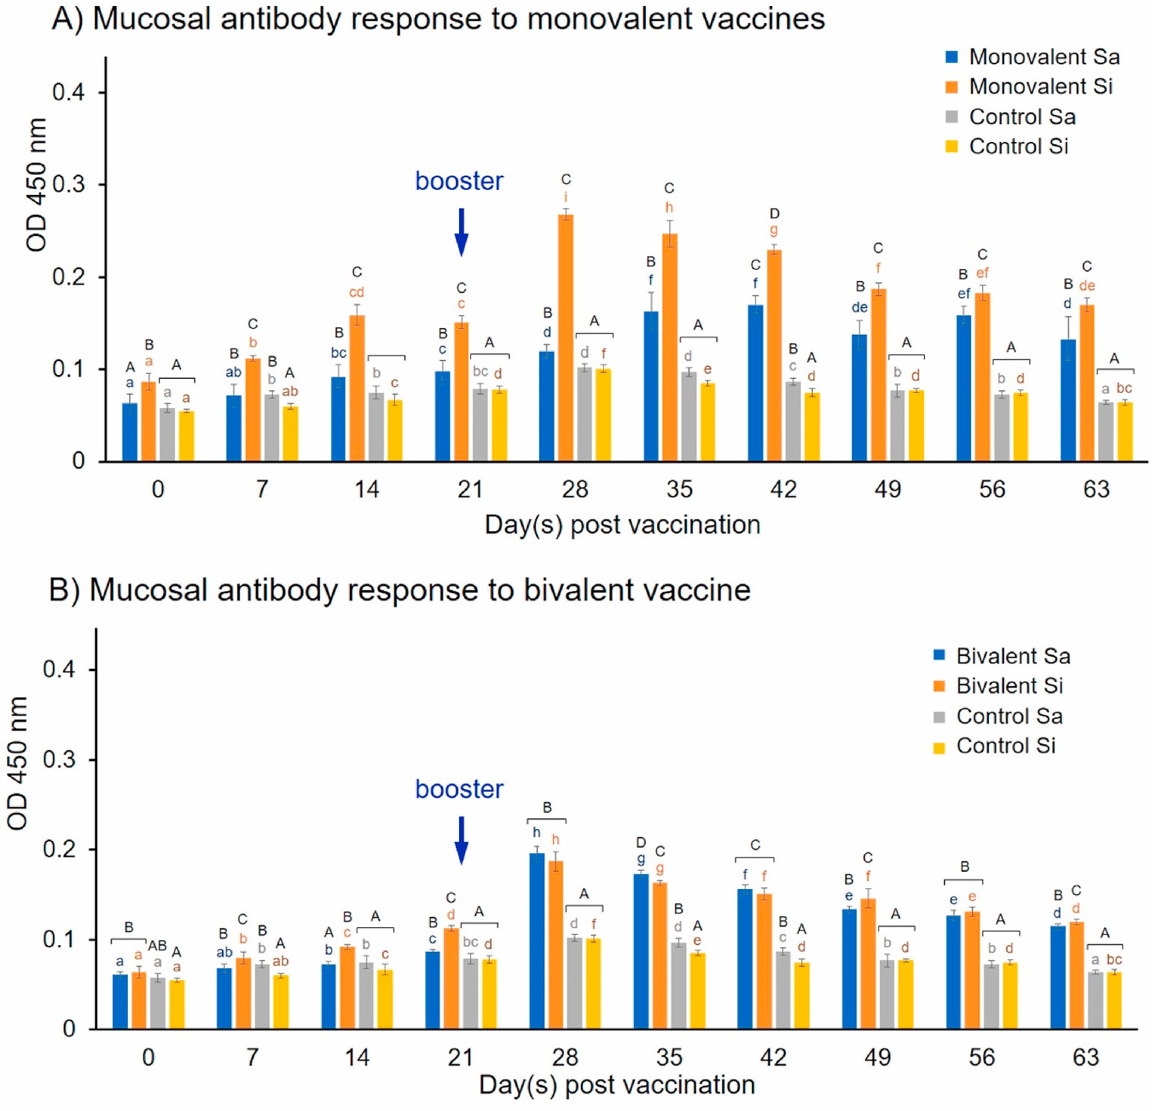

**Fig. 2.** Mucosal antibody titers of Asian seabass following immunization with the monovalent inactivated vaccines (A) and bivalent vaccine (B) as determined by ELISA. Mucosal antibody titer was assayed with 1:8 dilutions, measured at OD 450 nm. Significant differences (*P <* 0.05) within the same days are indicated by capital letters, and significant differences between days are indicated by small letters.

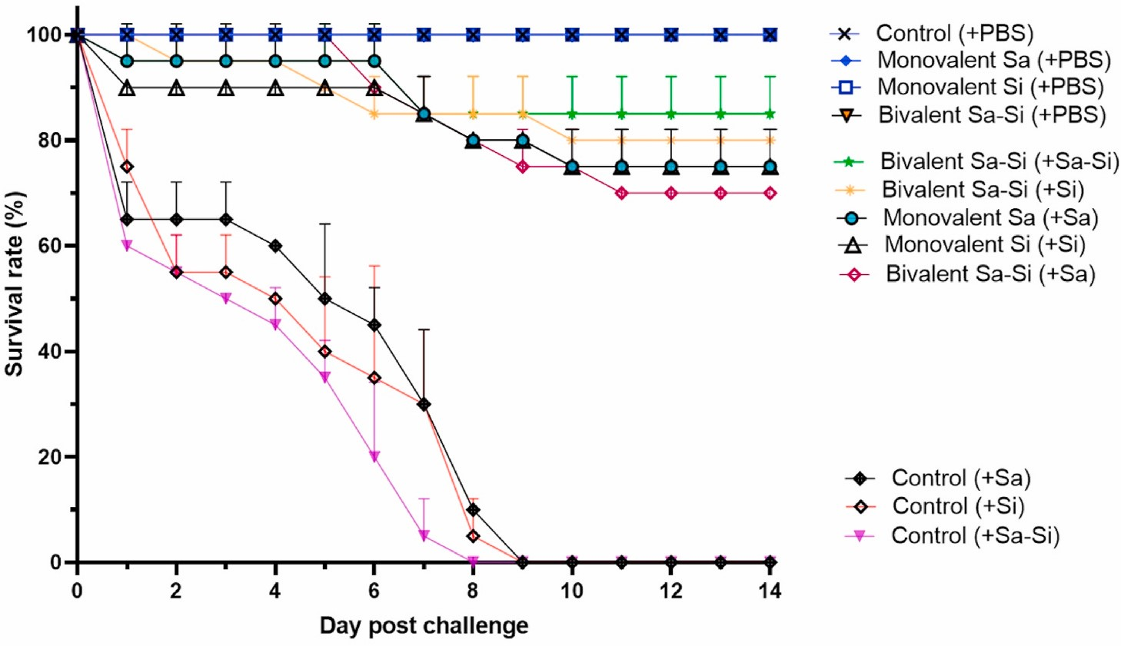

**Fig. 3.** Survival rate of Asian seabass from vaccinated and non-vaccinated control groups after challenging with PBS buffer (+PBS), single S. agalactiae (+Sa), single S. iniae (+Si) or combined S. agalactiae and S. iniae (+Sa-Si). Each treatment was performed in duplicate with 10 fish per tank. The upper half part of standard deviation bars is shown.

Understanding specific immune response kinetics in both systemic and mucosal systems is the scientific base for the development of an effective vaccination scheme for Asian seabass, especially when more than one antigen is combined. In the present study, it was revealed that the fish immunized with either inactivated Sa, Si, or combined Sa-Si were able to induce specific antibody IgM with similar response kinetics in both serum and mucus. However, the antibody titer in the serum was obviously higher than that in the mucus. Similar results were reported in Asian seabass following vaccination with inactivated *S. iniae* [35] and Nile tilapia vaccinated with formalin-killed *Flavobacterium columnare* [26]. Interestingly, the vaccines were administered by intraperitoneal injection, however, the specific IgM was increasingly detected in both serum and mucus with similar response kinetics. This suggests two possible scenarios; 1) the specific IgM produced in the serum might be transferred to the mucus by an unknown mechanism; or 2) it is locally produced in the skin. One of the limitations that precludes a confirmation, in this case, is that the other mucosal antibodies viz., IgT and IgZ were not investigated in this study due to unavailability of respective antibodies.

Antibodies that exist in mucosal surfaces are the essential primary defense mechanism for preventing infections from initial invasion [36, 37]. Deboutteville et al. (2006) reported that Asian seabass, in common with other finfish species, has both serum and cutaneous, mucosal antibody responses to monovalent *S. iniae* vaccine on day 21 post-vaccination. The present study revealed a continuously long-term response-kinetics (63 days) of the immunized fish with not only a single antigen but also with a combination of two antigens in one vaccine. Suppression of antibody titer in the bivalent Sa-Si group compared to monovalent Sa and Si is possibly due to antigen competition of two similar, closely related Gram-positive bacteria [31,38,39]. Thus, further studies are required on optimization of antigen combination (e.g., types, doses) and adjuvant types to enhance the elicitation of the optimal antibody response in combined vaccines, before their future application in Asian seabass.

Rapid elevation in the specific antibody levels by administration of a booster dose suggests a successful memory induction. This theoretically resulted in a subpopulation of memory B lymphocytes in the adaptive immune system that memorizes the antigen from the initial exposure and is rapidly activated to produce a large amount of the antibodies when repeatedly exposed to the same antigen in the booster dose [40, 41]. Such memory lymphocytes are durable cells that play an important role in long-lasting protection against invaders [42]. The result obtained in this study complies with the adaptive immunity principle mentioned above, which explains the fact that the vaccinated fish with declined antibody titer at the time of challenge still had a high survival.

To our knowledge, this study is the first achieved research on specific humoral immune response kinetics of Asian seabass following immunization with the inactivated *S. agalactiae* and *S. iniae* in the form of monovalent and bivalent vaccines. Although the antibody titer was suppressed when combining two antigens, the protective efficacy of the bivalent vaccine was not reduced. Thus, a combination of *S. agalactiae* and *S. iniae* in one injectable vaccine is highly promising for the prevention of streptococcosis in farmed Asian seabass.

# CRediT authorship contribution statement

**Nguyen Giang Thu Lan:** Data curation, Formal analysis, Investigation, Methodology, Writing - original draft, Writing - review & editing. **Krishna R. Salin:** Conceptualization, Data curation, Investigation, Methodology, Project administration, Supervision, Writing - review & editing. **Siwaporn Longyant:** Investigation, Writing - review & editing. **Saengchan Senapin:** Conceptualization, Formal analysis, Investigation, Supervision, Writing - review & editing. **Ha Thanh Dong:** Conceptualization, Data curation, Formal analysis, Investigation, Methodology, Project administration, Supervision, Writing - original draft, Writing - review & editing.

**Declaration of competing interest**

The authors declare no conflict of interest.

# Acknowledgments

This research was partially supported by a research fund from UK government - Department of Health and Social Care (DHSC), Global AMR Innovation fund (GAMRIF) and the International Development Research Center (IDRC), Ottawa, Canada (Grant no. 109050-003) to H. T.D., and BIOTEC Fellow Research Grant (P-19-50170) to S.S.; N.G.T.L. received the AITCV Silver Anniversary Scholarship from the Asian Institute of Technology, Thailand. The authors would like to thank Ms Suwimon Taengphu and Ms Pattanan Yatip from Centex Shrimp (BIOTEC/Mahidol University) for technical assistance.

# References

1. F.A.O. Fisheries, Aquaculture, Cultured Aquatic Species Information Programme *Lates calcarifer*, Block, 1790. [http://www.fao.org/fishery/culturedspecies/Lates_ca](http://www.fao.org/fishery/culturedspecies/Lates_calcarifer/en) [lcarifer/en.](http://www.fao.org/fishery/culturedspecies/Lates_calcarifer/en)
2. [D. Lawley, Repositioning Australian Farmed Barramundi: Online Consumer Survey](http://refhub.elsevier.com/S1050-4648(20)30718-X/sref2) [Findings, University of Sunshine Coast, Sunshine Coast, QLd, 2010](http://refhub.elsevier.com/S1050-4648(20)30718-X/sref2).
3. N.A. Robinson, G. Schipp, J. Bosmans, D.R. Jerry, Modelling selective breeding in protandrous, batch-reared Asian sea bass (*Lates calcarifer*, Bloch) using walkback selection, Aquacult. Res. 41 (2010) e643–e655, [https://doi.org/10.1111/j.1365- 2109.2010.02584.x.](https://doi.org/10.1111/j.1365-2109.2010.02584.x)
4. [M. Boonyaratpalin, T. Pechmanee, S. Chungyampin, J. Buranapanidgit, Feed, Feeding and Nutritional Deficiency in Seabass 1, Technical Paper, National](http://refhub.elsevier.com/S1050-4648(20)30718-X/sref4) [Institute of Coastal Aquaculture, Songkhla, Department of Fisheries, Ministry of Agriculture and Cooperatives, 1989, pp. 1–12](http://refhub.elsevier.com/S1050-4648(20)30718-X/sref4).
5. P.V. Khang, T.H. Phuong, N.K. Dat, W. Knibb, N.H. Nguyen, An 8-year breeding program for asian seabass *Lates calcarifer*: genetic evaluation, experiences, and challenges, Front. Genet. 9 (2018) 191, [https://doi.org/10.3389/](https://doi.org/10.3389/fgene.2018.00191) [fgene.2018.00191](https://doi.org/10.3389/fgene.2018.00191).
6. B.J. Fenner, Q. Du, W. Goh, R. Thiagarajan, H.K. Chua, J. Kwang, Detection of betanodavirus in juvenile barramundi, *Lates calcarifer* (Bloch), by antigen capture ELISA, J. Fish. Dis. 29 (2006) 423–432, [https://doi.org/10.1111/j.1365- 2761.2006.00736.x.](https://doi.org/10.1111/j.1365-2761.2006.00736.x)
7. Y.C. Wu, Y.H. Kai, S.C. Chi, Persistently betanodavirus-infected barramundi (*Lates calcarifer*) exhibit resistances to red sea bream iridovirus infection, Dev. Comp. Immunol. 41 (2013) 666–674, [https://doi.org/10.1016/j.dci.2013.06.011.](https://doi.org/10.1016/j.dci.2013.06.011)
8. R. Pakingking, E.G. de Jesus-Ayson, O. Reyes, N. Brian Bautista, Immunization regimen in Asian sea bass (*Lates calcarifer*) broodfish: a practical strategy to control vertical transmission of nervous necrosis virus during seed production, Vaccine 36 (33) (2018) 5002–5009, <https://doi.org/10.1016/j.vaccine.2018.07.015>.
9. S. Gibson-Kueh, D. Chee, J. Chen, Y.H. Wang, S. Tay, L.N. Leong, M.L. Ng, J. B. Jones, P.K. Nicholls, H.W. Ferguson, The pathology of “scale drop syndrome” in Asian seabass, *Lates calcarifer* Bloch, a first description, J. Fish. Dis. 35 (1) (2012) 19–27, [https://doi.org/10.1111/j.1365-2761.2011.01319.x.](https://doi.org/10.1111/j.1365-2761.2011.01319.x)
10. [A. de Groof, L. Guelen, M. Deijs, Y. van der Wal, M. Miyata, K.S. Ng, A novel virus](http://refhub.elsevier.com/S1050-4648(20)30718-X/sref10) [causes scale drop disease in *Lates calcarifer*, PLoS Pathog. 11 (2015), e1005074.](http://refhub.elsevier.com/S1050-4648(20)30718-X/sref10) [11] [S. Jitrakorn, W. Gangnonngiw, M. Bunnontae, O. Manajit, T. Rattanarojpong,](http://refhub.elsevier.com/S1050-4648(20)30718-X/sref11) [P. Chaivisuthangkura, H.T. Dong, V. Saksmerprome, Infectious cell culture system](http://refhub.elsevier.com/S1050-4648(20)30718-X/sref11) [for concurrent propagation and purification of *Megalocytivirus* ISKNV and nervous](http://refhub.elsevier.com/S1050-4648(20)30718-X/sref11) [necrosis virus from Asian Sea bass (*Lates calcarifer*), Aquaculture 520 (2020) 73493.](http://refhub.elsevier.com/S1050-4648(20)30718-X/sref11)
11. K. Thanasaksiri, R. Takano, K. Fukuda, T. Chaweepack, J. Wongtavatchai, Identification of infectious spleen and kidney necrosis virus from farmed barramundi *Lates calcarifer* in Thailand and study of its pathogenicity, Aquaculture (2018), <https://doi.org/10.1016/j.aquaculture.2018.09.035>.
12. [H.T. Dong, S. Taengphu, P. Sangsuriya, W. Charoensapsri, K. Phiwsaiya,](http://refhub.elsevier.com/S1050-4648(20)30718-X/sref13) [T. Sornwatana, P. Khunrae, T. Rattanarojpong, S. Senapin, Recovery of *Vibrio*](http://refhub.elsevier.com/S1050-4648(20)30718-X/sref13)[*harveyi* from scale drop and muscle necrosis disease in farmed barramundi, *Lates calcarifer* in Vietnam. Aquaculture 473 (2017) 89–96](http://refhub.elsevier.com/S1050-4648(20)30718-X/sref13).
13. J. Ransangan, S. Mustafa, Identification of *Vibrio harveyi* isolated from diseased asian seabass *Lates calcarifer* by use of 16S ribosomal DNA sequencing, J Aquat 21 (3) (2009) 150–155, <https://doi.org/10.1577/H09-002.1>.
14. E.S. Bromage, A. Thomas, L. Owens, *Streptococcus iniae*, a bacterial infection in barramundi *Lates calcarifer*, Dis. Aquat. Org. 36 (1999) 177–181, [https://doi.org/](https://doi.org/10.3354/dao036177) [10.3354/dao036177](https://doi.org/10.3354/dao036177).
15. J.H. Creeper, N.B. Buller, An outbreak of *Streptococcus iniae* in barramundi (*Lates calcarifer*) in freshwater cage culture, Aust. Vet. J. 84 (2006) 408–411, [https://doi.](https://doi.org/10.1111/j.17510813.2006.00058.x) [org/10.1111/j.17510813.2006.00058.x](https://doi.org/10.1111/j.17510813.2006.00058.x).
16. [J.D. Humphrey, S. Benedict, L. Small, Streptococcosis, Trypanosomiasis, Vibriosis](http://refhub.elsevier.com/S1050-4648(20)30718-X/sref17) [and Bacterial Gill Disease in Sea-Caged Barramundi at Port Hurd, Bathurst Island,](http://refhub.elsevier.com/S1050-4648(20)30718-X/sref17) [July-August 2005, in: Fishery Report (Northern Territory, 98, Fisheries Division),](http://refhub.elsevier.com/S1050-4648(20)30718-X/sref17) [2010](http://refhub.elsevier.com/S1050-4648(20)30718-X/sref17).
17. [T.H. Vi, V.D.H. Quyen, N.H. Dung, H.I.( Wergeland, Experimental *Streptococcus iniae* infection in barramundi (*Lates calcarifer)* cultured in Vietnam, Int J of Aquat](http://refhub.elsevier.com/S1050-4648(20)30718-X/sref18) [Sci 4 (1) (2013) 3–12](http://refhub.elsevier.com/S1050-4648(20)30718-X/sref18).
18. P. Kayansamruaj, H.T. Dong, V.V. Nguyen, H.D. Le, N. Pirarat, C. Rodkhum, Susceptibility of freshwater rearing Asian seabass (*Lates calcarifer)* to pathogenic *Streptococcus iniae*, Aquacult. Res. 48 (2015) 711–718, [https://doi.org/10.1111/](https://doi.org/10.1111/are.12917) [are.12917.](https://doi.org/10.1111/are.12917)
19. W. Agnew, A. Barnes, *Streptococcus iniae*: an aquatic pathogen of global veterinary significance and a challenging candidate for reliable vaccination, Vet. Microbiol.

122 (1–2) (2007) 1–15, [https://doi.org/10.1016/j.vetmic.2007.03.002.](https://doi.org/10.1016/j.vetmic.2007.03.002)

1. [N. Suanyuk, N. Sukkasame, N. Tanmark, N. Yoshida, T. Itami, R.L. Thune,](http://refhub.elsevier.com/S1050-4648(20)30718-X/sref21) [C. Tantikitti, K. Supamattaya, *Streptococcus iniae* infection in cultured Asian seabass](http://refhub.elsevier.com/S1050-4648(20)30718-X/sref21)

[(*Lates calcarifer*) and red tilapia (*Oreochromis sp.*) in southern Thailand, Songklanakarin J. Sci. Technol. 32 (4) (2010) 341–348](http://refhub.elsevier.com/S1050-4648(20)30718-X/sref21).

1. P. Kayansamruaj, C. Soontara, S. Unajak, H.T. Dong, C. Rodkhum, H. Kondo, I. Hirono, N. Areechon, Comparative genomics inferred two distinct populations of piscine pathogenic *Streptococcus agalactiae*, serotype Ia ST7 and serotype III ST283, in Thailand and Vietnam, Genomics 111 (2019) 1657–1667, [https://doi.org/ 10.1016/j.ygeno.2018.11.016.](https://doi.org/10.1016/j.ygeno.2018.11.016)
2. [A. Adams, R. Subasinghe, Use of Fish Vaccines in Aquaculture (Including Methods of Administration), first ed., Veterinary Vaccines for Livestock. *The Food and*](http://refhub.elsevier.com/S1050-4648(20)30718-X/sref23)[*Agriculture Organization of the United Nations*, 2019](http://refhub.elsevier.com/S1050-4648(20)30718-X/sref23).
3. [C. Uribe, H. Folch, R. Enriquez, G. Moran, Innate and adaptive immunity in teleost fish: a review, Vet Med-Czech 56 (2011) 486–503](http://refhub.elsevier.com/S1050-4648(20)30718-X/sref24).
4. B. Magnadottir, Immunological control of fish diseases, Mar. Biotechnol. 12 (4) (2010) 361–379, <https://doi.org/10.1007/s10126-010-9279-x>.
5. L.D. Grabowski, S.E. LaPatra, K.D. Cain, Systemic and mucosal antibody response in tilapia, *Oreochromis niloticus (L.)*, following immunization with *Flavobacterium columnare*, J. Fish. Dis. 27 (10) (2004) 573–581, [https://doi.org/10.1111/j.1365-](https://doi.org/10.1111/j.1365-2761.2004.00576.x) [2761.2004.00576.x.](https://doi.org/10.1111/j.1365-2761.2004.00576.x)
6. [T. Soonthonsrima, P. Wangman, C. Pengsuk, P. Sithigorngul, S. Longyant,](http://refhub.elsevier.com/S1050-4648(20)30718-X/sref27) [Production of monoclonal antibody specific to immunoglobulin of Asian sea bass](http://refhub.elsevier.com/S1050-4648(20)30718-X/sref27) [*Lates calcarifer*, Burapha Sci J 24 (2019) 1237–1249.](http://refhub.elsevier.com/S1050-4648(20)30718-X/sref27)
7. J.H.Y. Lin, T.Y. Chen, M.S. Chen, H.E. Chen, R.L. Chou, T.I. Chen, H.L. Yang, Vaccination with three inactivated pathogens of cobia (Rachycentron canadum) stimulates protective immunity, Aquaculture 255 (1–4) (2006) 125–132, [https:// doi.org/10.1016/j.aquaculture.2005.12.005,](https://doi.org/10.1016/j.aquaculture.2005.12.005) 31.
8. [D.F. Amend, Potency testing of fish vaccines, Dev. Biol. Stand. 49 (1981) 447–454](http://refhub.elsevier.com/S1050-4648(20)30718-X/sref29).
9. T.T.T. Nguyen, H.T. Nguyen, Y.C. Chen, H.H. Hoang, P.C. Wang, S.C. Chen,

Effectiveness of a divalent *Streptococcus dysgalactiae* inactivated vaccine in cobia (*Rachycentron canadum L.*), Aquaculture 495 (2018) 130–135, [https://doi.org/ 10.1016/j.aquaculture.2018.05.034](https://doi.org/10.1016/j.aquaculture.2018.05.034).

1. C.A. Shoemaker, B.R. LaFrentz, P.H. Klesius, Bivalent vaccination of sex reversed hybrid tilapia against *Streptococcus iniae* and *Vibrio vulnificus*, Aquaculture 354–355 (2012) 45–49, <https://doi.org/10.1016/j.aquaculture.2012.04.033>.
2. [T.P.T. Evelyn, Finfish immunology and its use in preventing infectious diseases in](http://refhub.elsevier.com/S1050-4648(20)30718-X/sref32) [cultured finfish, in: C.R. Lavilla-Pitogo, E.R. Cruz-Lacierda (Eds.), Dis in Asian Aquaculture IV*.* Fish Health Section, Asian Fisheries Society, Manila, 2002, pp. 303–324](http://refhub.elsevier.com/S1050-4648(20)30718-X/sref32).
3. I. Sommerset, B. Krossoy, E. Biering, P. Frost, Vaccines for fish in aquaculture, Expert Rev. Vaccines 4 (1) (2005) 89–101, [https://doi.org/10.1586/](https://doi.org/10.1586/14760584.4.1.89) [14760584.4.1.89](https://doi.org/10.1586/14760584.4.1.89).
4. [L. Grisez, Z. Tan, Vaccine development for Asian aquaculture, in: P. Walker, R. Lester, M.G. Bondad-Reantaso Dis (Eds.), Asian Aquaculture V, 2005,](http://refhub.elsevier.com/S1050-4648(20)30718-X/sref34) [pp. 483–494](http://refhub.elsevier.com/S1050-4648(20)30718-X/sref34).
5. J. Delamare-Deboutteville, D. Wood, A.C. Barnes, Response and function of cutaneous mucosal and serum antibodies in barramundi (*Lates calcarifer*) acclimated in seawater and freshwater, Fish Shellfish Immunol. 21 (1) (2006) 92–101, <https://doi.org/10.1016/j.fsi.2005.10.005>.
6. I. Salinas, Y.-A. Zhang, J.O. Sunyer, Mucosal immunoglobulins and B cells of teleost fish, Dev. Comp. Immunol. 35 (2011) 1346–1365, [https://doi.org/10.1016/](https://doi.org/10.1016/j.dci.2011.11.009) [j.dci.2011.11.009.](https://doi.org/10.1016/j.dci.2011.11.009)
7. [I. Salinas, The mucosal immune system of teleost fish, Biology 4 (2015) 525–539](http://refhub.elsevier.com/S1050-4648(20)30718-X/sref37).
8. J.D. Hunt, L.E. Brown, D.C. Jackson, Antigenic competition, Encyclopedia of Life Sci (2001), <https://doi.org/10.1038/npg.els.0000948>.
9. [S. Nikoskelainen, S. Verho, S. Jarvinen, J. Madetoja, T. Wiklund, E.-M. Lilius,](http://refhub.elsevier.com/S1050-4648(20)30718-X/sref39)

[Multiple whole bacterial antigens in polyvalent vaccine may result in inhibition of](http://refhub.elsevier.com/S1050-4648(20)30718-X/sref39) [specific responses in rainbow trout (*Oncorhynchus mykiss*), Fish Shellfish Immunol.](http://refhub.elsevier.com/S1050-4648(20)30718-X/sref39) [22 (2007) 206–217](http://refhub.elsevier.com/S1050-4648(20)30718-X/sref39).

1. D.L. Farber, M.G. Netea, A. Radbruch, K. Rajewsky, R.M. Zinkernagel,

Immunological memory: lessons from the past and a look to the future, Nat. Rev.

Immunol. 16 (2) (2016) 124–128, [https://doi.org/10.1038/nri.2016.13.](https://doi.org/10.1038/nri.2016.13)

1. K.L. Randall, Generating humoral immune memory following infection or vaccination, Expert Rev. Vaccines 9 (2010) 1083–1093, [https://doi.org/10.1586/](https://doi.org/10.1586/erv.10.103) [erv.10.103](https://doi.org/10.1586/erv.10.103).
2. [K.A. Abul, H.H.L. Andrew, P. Shiv, Basic Immunology: Functions and Disorders of](http://refhub.elsevier.com/S1050-4648(20)30718-X/sref42) [the Immune System, fifth ed., Elsevier, Philadelphia, United States, 2015](http://refhub.elsevier.com/S1050-4648(20)30718-X/sref42).